Hive Activity

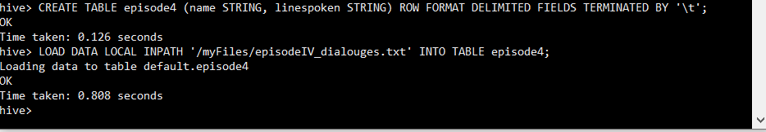

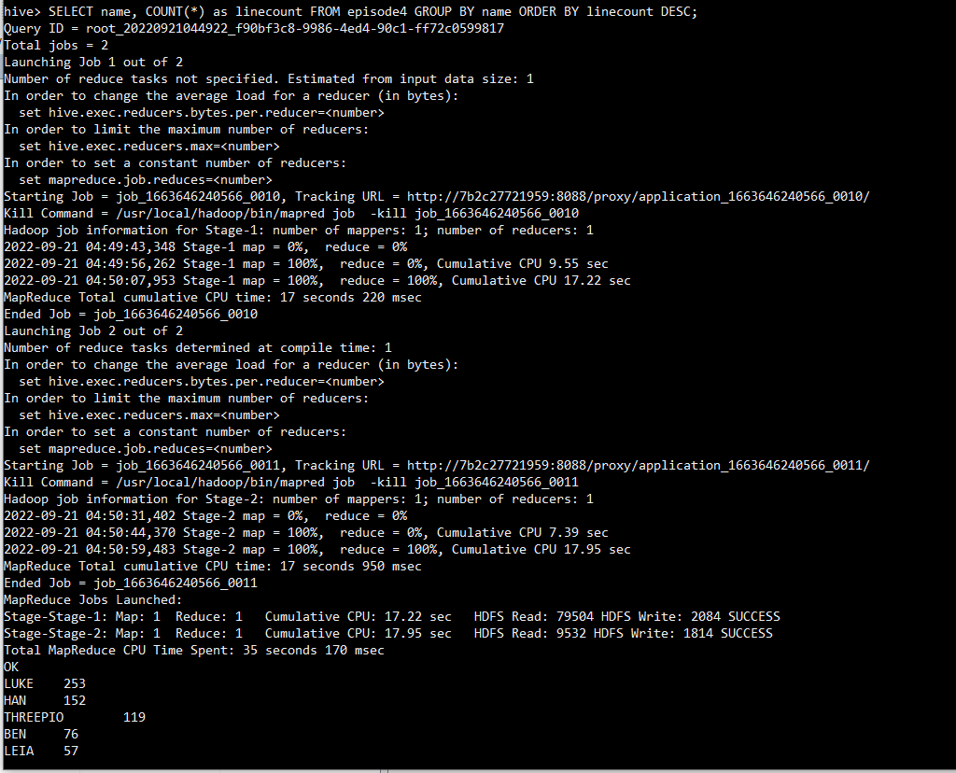

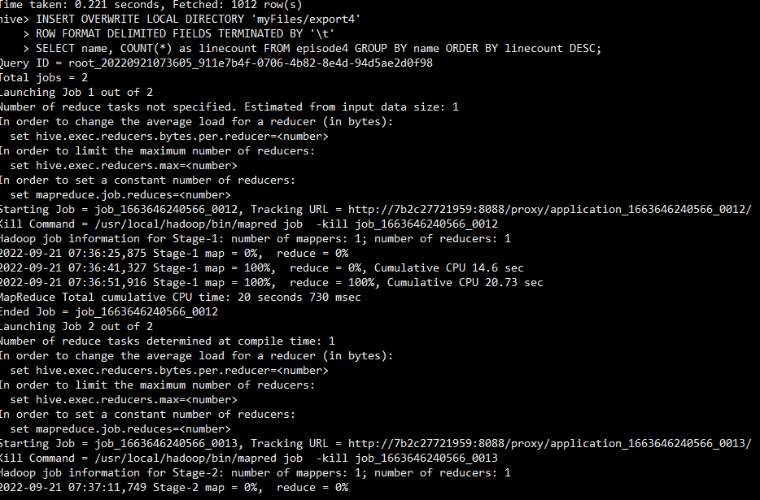

CREATE TABLE episode4 (name STRING, linespoken STRING) ROW FORMAT DELIMITED FIELDS TERMINATED BY '\t';

LOAD DATA LOCAL INPATH '/episodeIV_dialouges.txt' INTO TABLE episode4;

SELECT name, COUNT(*) as linecount FROM episode4 GROUP BY name ORDER BY linecount DESC;

INSERT OVERWRITE LOCAL DIRECTORY '/export4' ROW FORMAT DELIMITED FIELDS TERMINATED BY '\t' SELECT name, COUNT(*) as linecount FROM office.episode4 GROUP BY name ORDER BY linecount DESC;

**Count of Luke in EpisodeIV**

select count(*) from office.episode4 where INSTR(linespoken,'Luke')>0;

INSERT OVERWRITE LOCAL DIRECTORY '/export8' ROW FORMAT DELIMITED FIELDS TERMINATED BY '\t' select count(*) from office.episode4 where INSTR(linespoken,'Luke')>0;